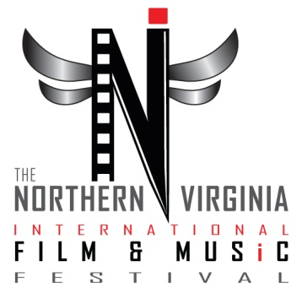
2017 FESTIVAL SUBMITTAL - BAND
PART I: ENTRY FORM

MUSICIAN AND OR PRODUCER INFORMATION

Name: Email:
Address: Website:
City: Phone:
State:
Country:

Your Title on this Project is: Writer Producer Musician Manager/Representative Other:

Submission Fee Schedule

Regular Deadline Late Deadline Extended Late Deadline
Jan. 03, 2017 Feb. 20, 2017 Mar. 02, 2017
Music / Band | $55 | $75 | $100

Band Information

Band Name: Genre:
Link to Performance. (Link can be emailed):
Check here, if sending DVD.

Submission Checklist (Fill all that apply).

Completed and Signed Entry Form Entry Fee
Video Demo Tape (DVD) / Internet Link EPK (Optional)
DVD or Link to Demo / Performance / Show (Minimum 30 Min. Set) SASE for Receipt (Optional)

*ACCEPTED BANDS MUST BE ABLE TO PERFORM AT THE MUSIC PORTION OF THE FESTIVAL AT THE STATE THEATRE IN FALLS CHURCH, VA*

2017 FESTIVAL SUBMITTAL
PART II: PAYMENT INFORMATION

ENTRY FEE: | $ | Less DISCOUNT CODE: | # | TOTAL FEE: | $

Credit Card

Name on Credit Card: Account Number:
Address: Exp. Date: /
CV Code:
City:
State: Visa Master Card
Zip Code: Discover American Express
Country:

*****Please make all checks or money orders payable to: Violent Hues Productions*****
MONEY ORDER # |  | CHECK #

CERTIFICATION OF ENTRANT

I have read, understood and complied with the rules and regulations. To the best of my knowledge, all statements in this document are true. This film, script or music is not subject to any litigation nor is any litigation threatened. I am duly authorized to submit this film/video/animation/musical performance to the Northern Virginia International Film & Music Festival. Should this film win an award I am authorized and or empowered by all parties legally representing this production to designate the following individuals to receive all awards. In the case where no recipient is designated, all prizes will be split equally between the director and the production company. I understand that the NOVA Fest committee will place my project in the proper category if necessary and I give the NOVA Fest the right to use my film, video, animation, performances and or experimental project as well as promotional stills, and information to promote my project as well as the NOVA Fest in any way the NOVA Fest sees fit.

Signature ___________________________________________________ Date: / /

Print Name:

Please mail this application along with payment (Made Payable to Violent Hues Productions) and all of your materials to:

The NOVA Fest
5810 Kingstowne Ctr. Dr.
Ste. 120
Alexandria, VA 22315

703.960.1970

Thank you!

